Design Principles - Law of Demeter (LoD)
# Source: AI Source: Provided by: [Data Path: Persons Table -> ID Column: 1, Name_En Column: Motasem Essam] -> From: [ChatGPT] on [1/23/2026]
The Law of Demeter is the principle that a module or object should only communicate with its immediate friends and not “reach through” multiple objects to get data.
👉 Think of it like asking your friend for help instead of messaging their entire network — keep interactions local.

🔑 Key Points
# Source: AI Source: Provided by: [Data Path: Persons Table -> ID Column: 1, Name_En Column: Motasem Essam] -> From: [ChatGPT] on [1/23/2026]
• Encourages minimal knowledge of other modules
• Reduces coupling between components
• Makes code more maintainable and flexible
• Supports encapsulation and modularity

❌ Bad Example
# Source: AI Source: Provided by: [Data Path: Persons Table -> ID Column: 1, Name_En Column: Motasem Essam] -> From: [ChatGPT] on [1/23/2026]
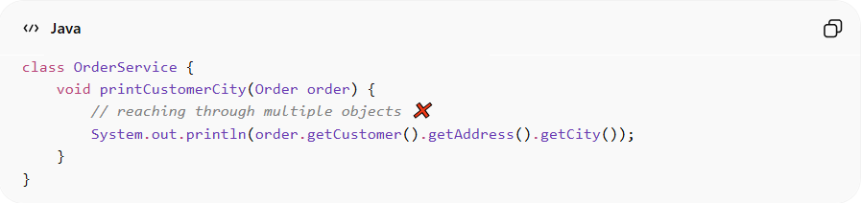
class OrderService {
void printCustomerCity(Order order) {
// reaching through multiple objects ❌
System.out.println(order.getCustomer().getAddress().getCity());
}
}
Problems:
• Violates encapsulation
• High coupling between Order, Customer, and Address
• Changing one class can break many others
• Hard to test or refactor

✅ Good Example
# Source: AI Source: Provided by: [Data Path: Persons Table -> ID Column: 1, Name_En Column: Motasem Essam] -> From: [ChatGPT] on [1/23/2026]
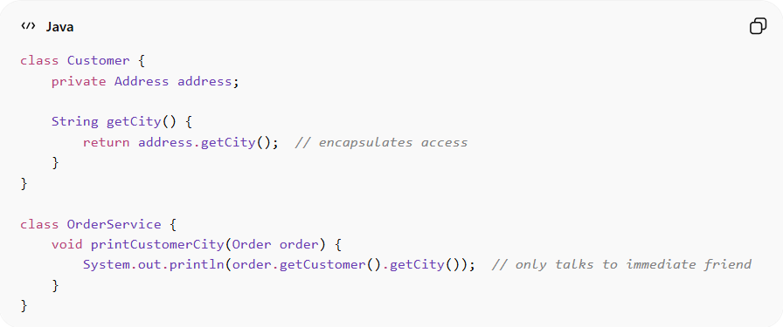
class Customer {
private Address address;

String getCity() {
return address.getCity(); // encapsulates access
}
}

class OrderService {
void printCustomerCity(Order order) {
System.out.println(order.getCustomer().getCity()); // only talks to immediate friend
}
}
Benefits:
• Minimizes dependencies between modules
• Easier to maintain, test, and extend
• Reduces risk when refactoring
• Supports modular, decoupled design

⚡ When to Apply
# Source: AI Source: Provided by: [Data Path: Persons Table -> ID Column: 1, Name_En Column: Motasem Essam] -> From: [ChatGPT] on [1/23/2026]
• Always — especially in object-oriented systems
• Works best with high cohesion and encapsulation
• Useful for service classes, APIs, and large modular applications
• Combine with DRY, KISS, and High Cohesion for clean architecture

